**7ET023 Dissertation appendices**

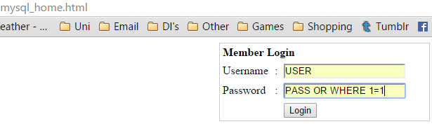Artefact:

1a) MySQL tautology attack

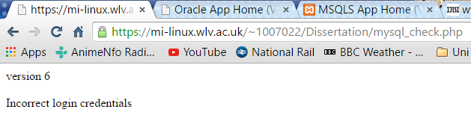1b) MySQL tautology attack results

1c) Oracle tautology attack

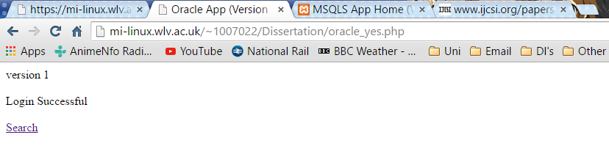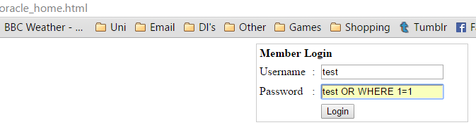1d) Oracle tautology attack results

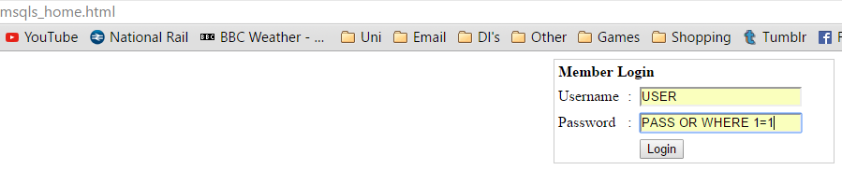1e) MSQLS tautology attack

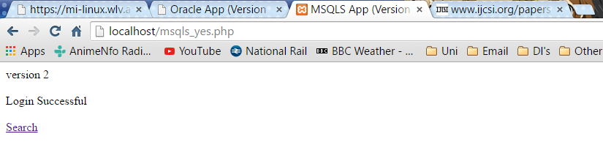1f) MSQLS tautology attack results

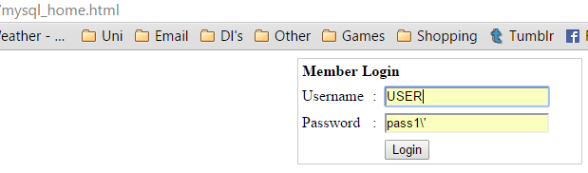2a) MySQL Illegal/Logically Incorrect Queries attack

2b) MySQL Illegal/Logically Incorrect Queries attack results

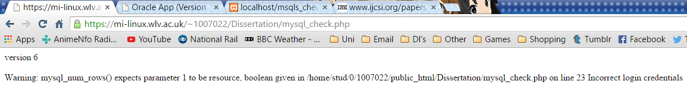

2c) Oracle Illegal/Logically Incorrect Queries attack

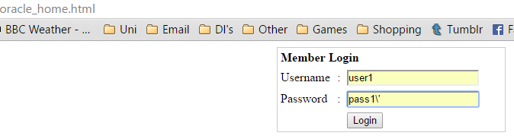

2d) Oracle Illegal/Logically Incorrect Queries attack results

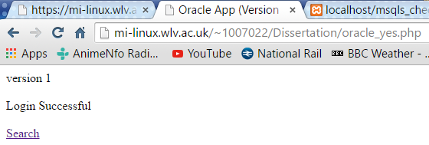

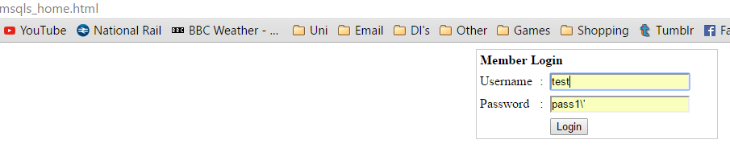2e) MSQLS Illegal/Logically Incorrect Queries attack

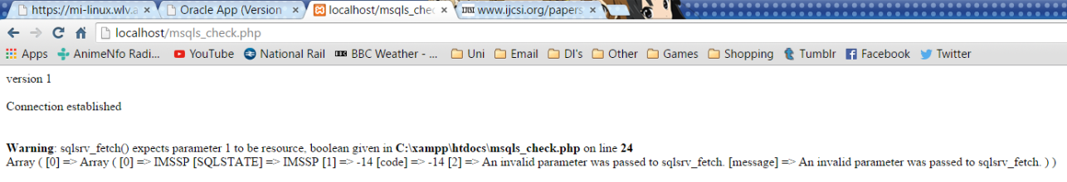2f) MSQLS Illegal/Logically Incorrect Queries attack results

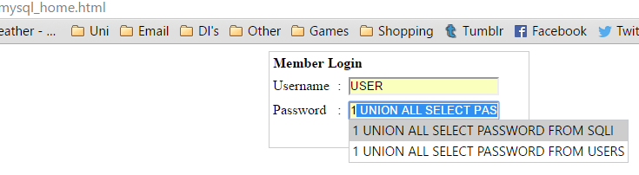

3a) MySQL Union Query attack

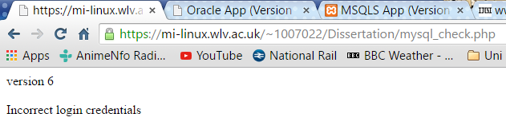3b) MySQL Union Query attack results

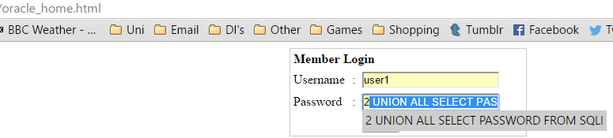3c) Oracle Union Query attack

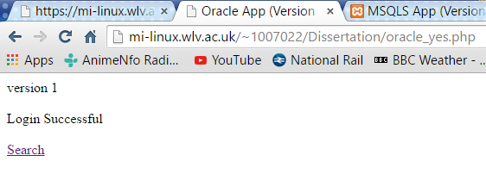3d) Oracle Union Query attack results

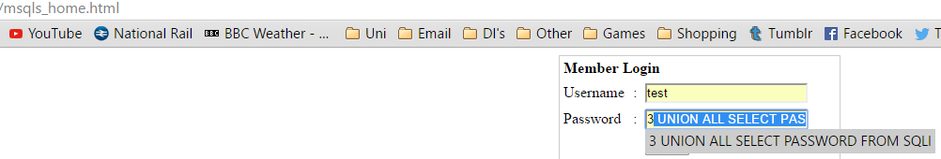3e) MSQLS Union Query attack

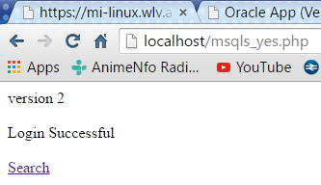3f) MSQLS Union Query attack results

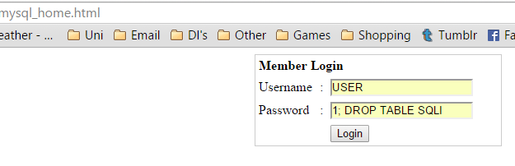4a) MySQL Piggy-backed Queries attack

4b) MySQL Piggy-backed Queries attack results

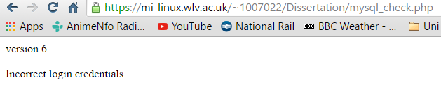

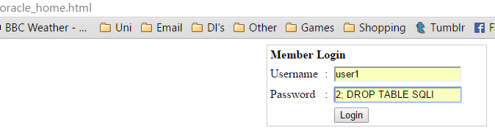4c) Oracle Piggy-backed Queries attack

4d) Oracle Piggy-backed Queries attack results

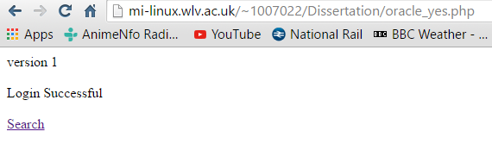

4e) MSQLS Piggy-backed Queries attack

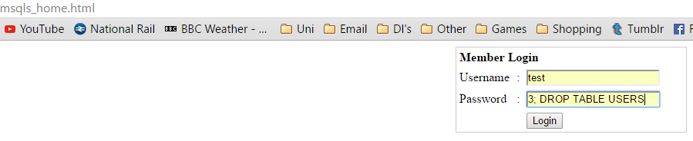

4f) MSQLS Piggy-backed Queries attack results

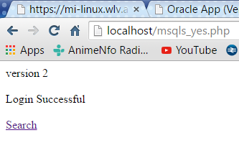

5a) MySQL Blind Injection attack

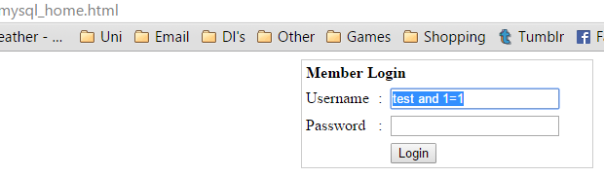

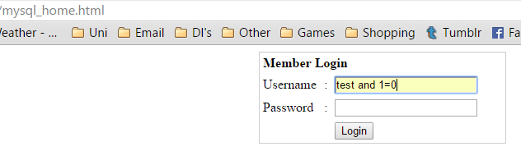

5b) MySQL Blind Injection attack results 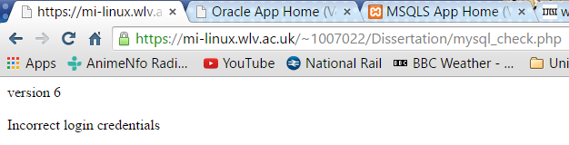

5c) Oracle Blind Injection attack

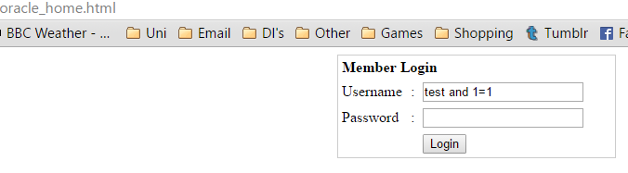

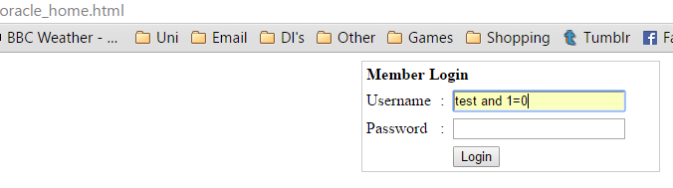

5d) Oracle Blind Injection attack results

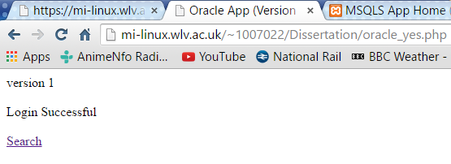

5e) MSQLS Blind Injection attack

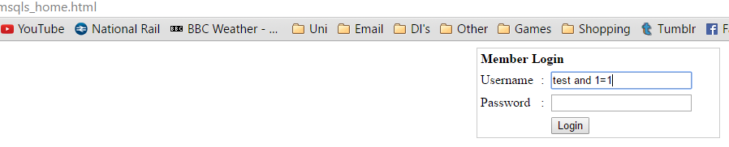

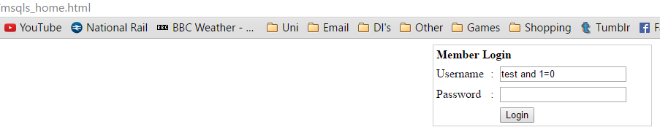

5f) MSQLS Blind Injection attack results

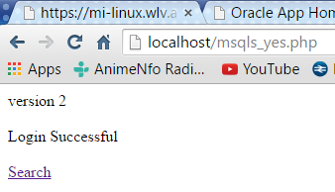

6a) MySQL Timing Attack

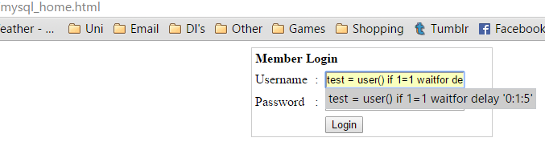

6b) MySQL Timing Attack results

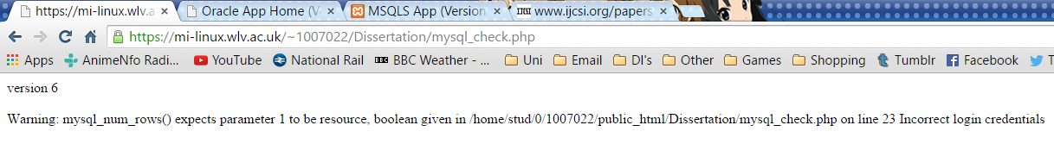

6c) Oracle Timing Attack

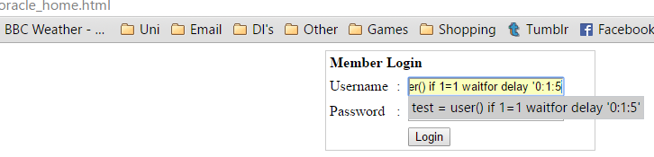

6d) Oracle Timing Attack results

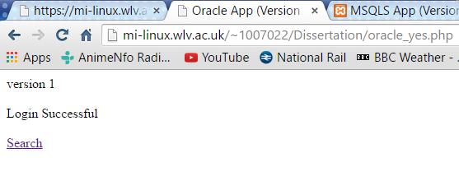

6e) MSQLS Timing Attack

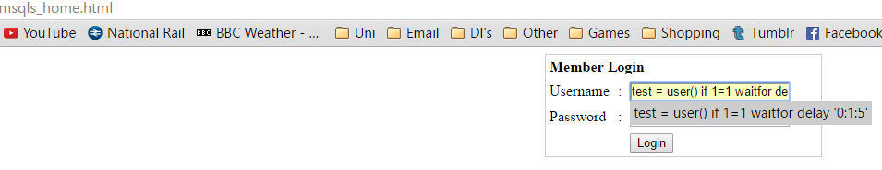

6f) MSQLS Timing Attack results

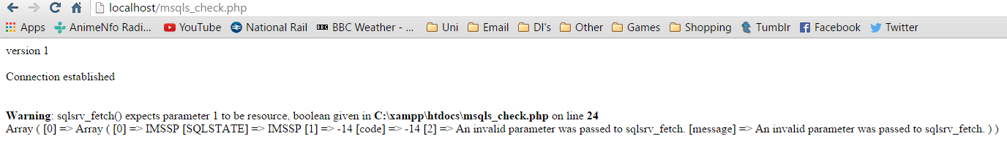

7a) MySQL Alternate Encodings Attack

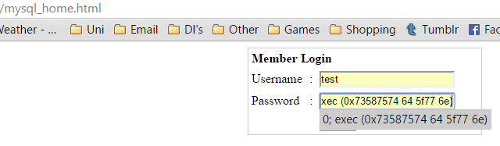

7b) MySQL Alternate Encodings Attack results

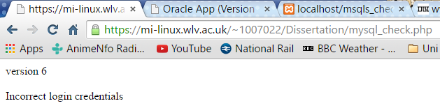

7c) Oracle Alternate Encodings Attack

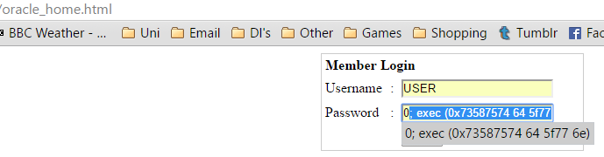

7d) Oracle Alternate Encodings Attack results

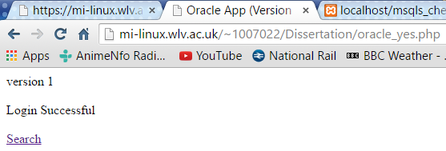

7e) MSQLS Alternate Encodings Attack

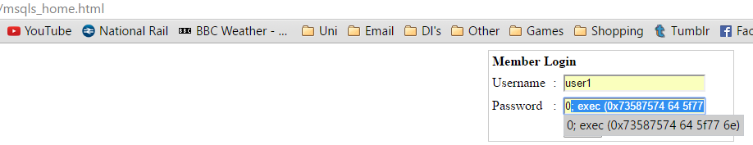

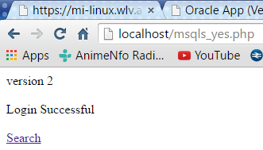7f) MSQLS Alternate Encodings Attack results

8a) SQLIA results

8b) Burp Suite testing

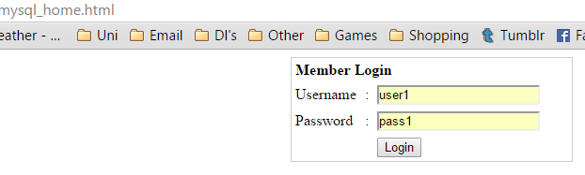

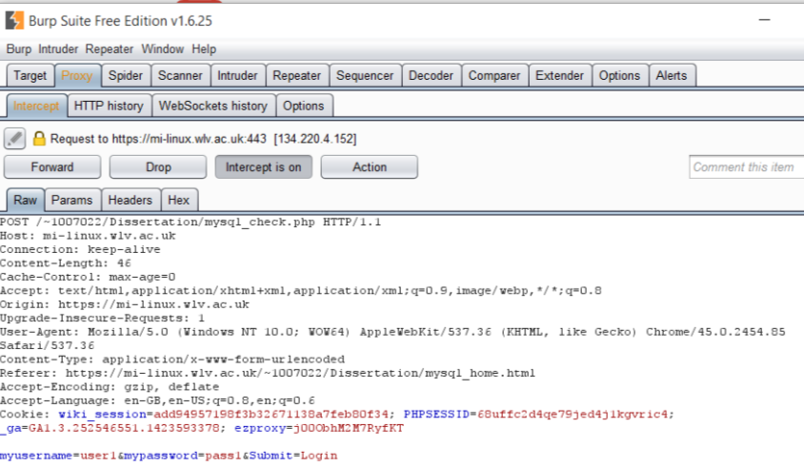Login request is sent.

Program detects and outputs details of the request before it can be sent.

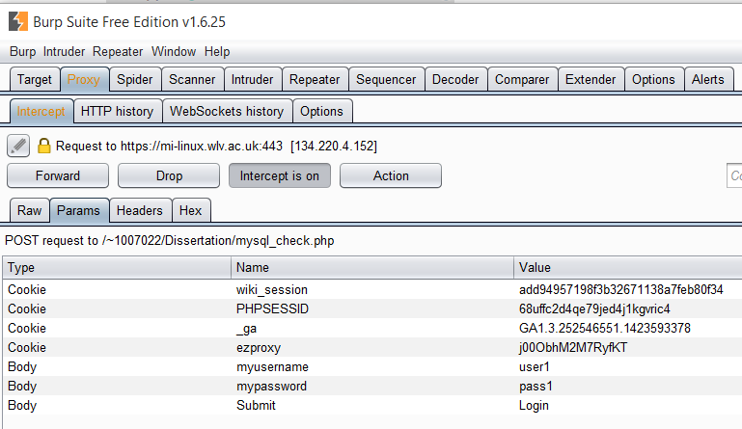Program goes further to show user input.

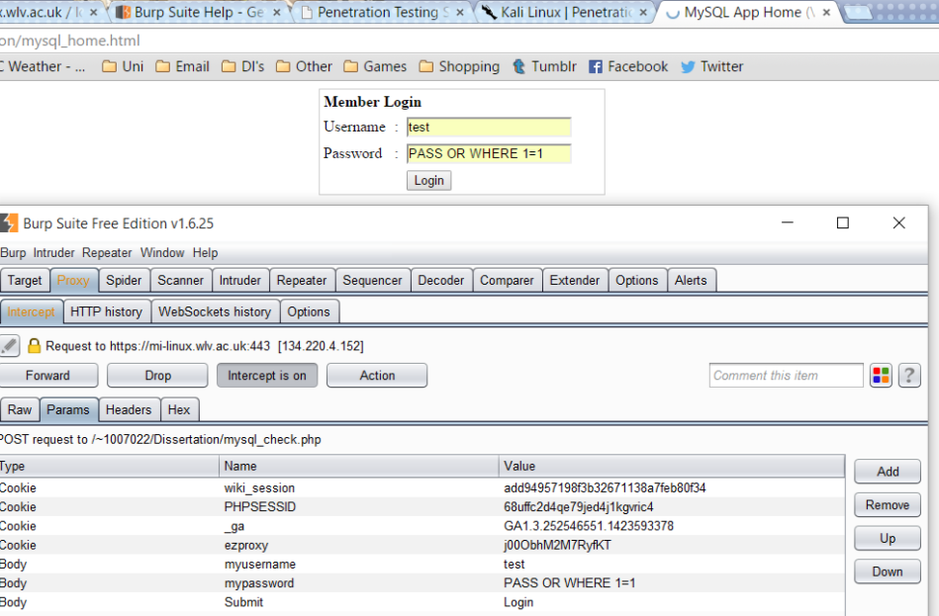Program detects another request, this time a SQL Injection attempt which is intercepted and its contents shown in order to determine whether it is hostile in nature.

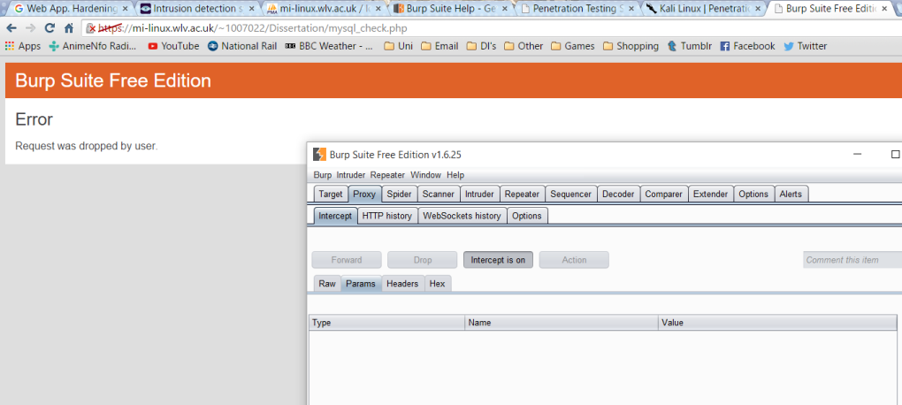

Program can then block the request by dropping it effectively detecting and preventing SQL injection.

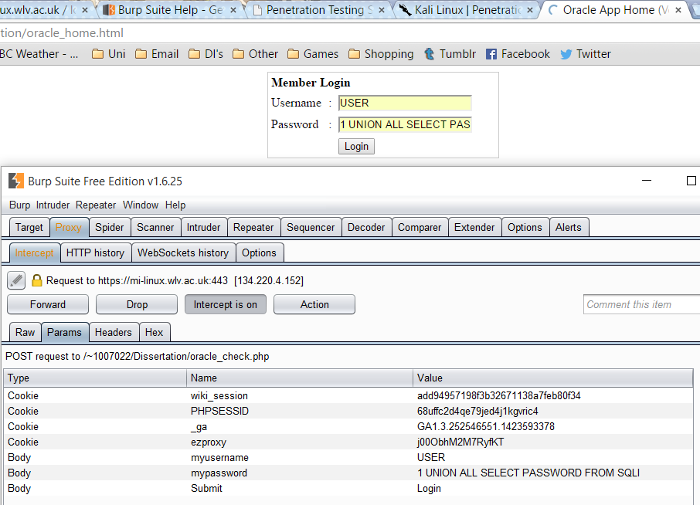

Oracle test

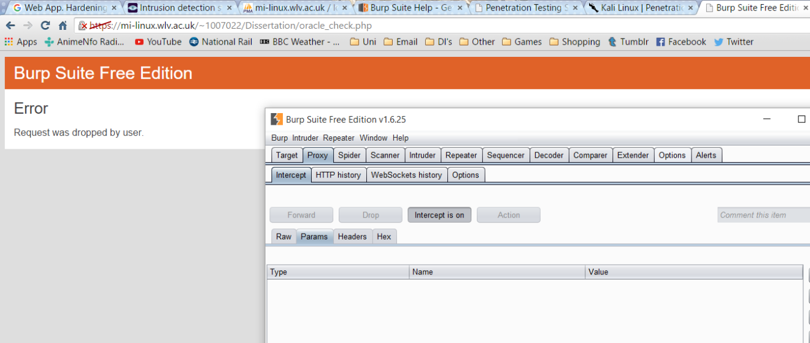

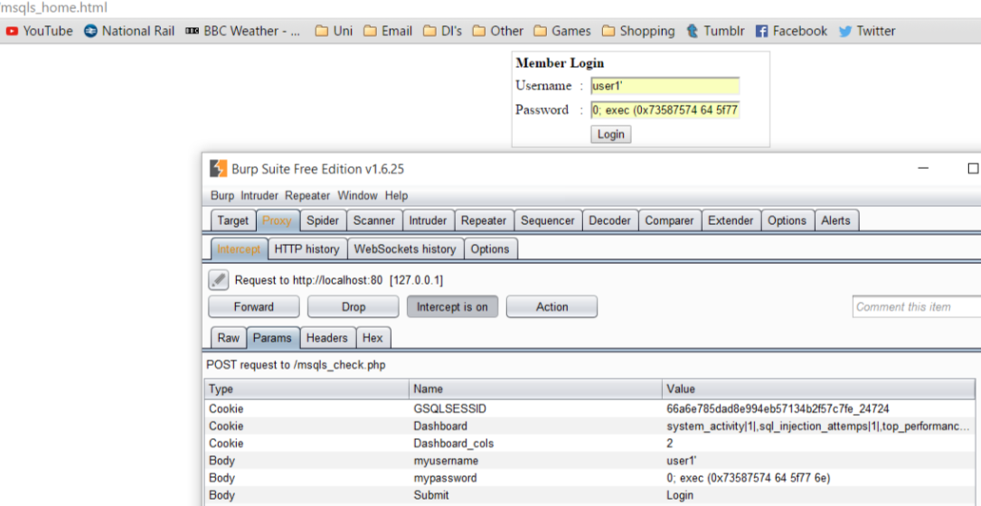

MSQLS test

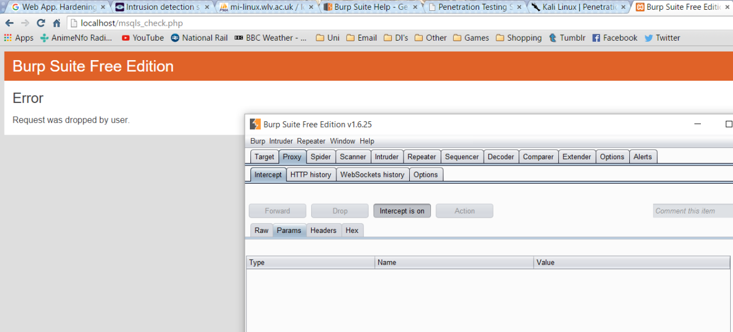

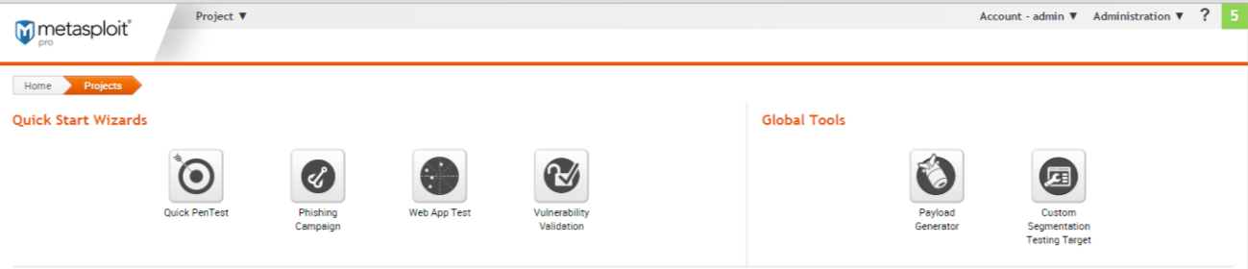8c) Metasploit testing

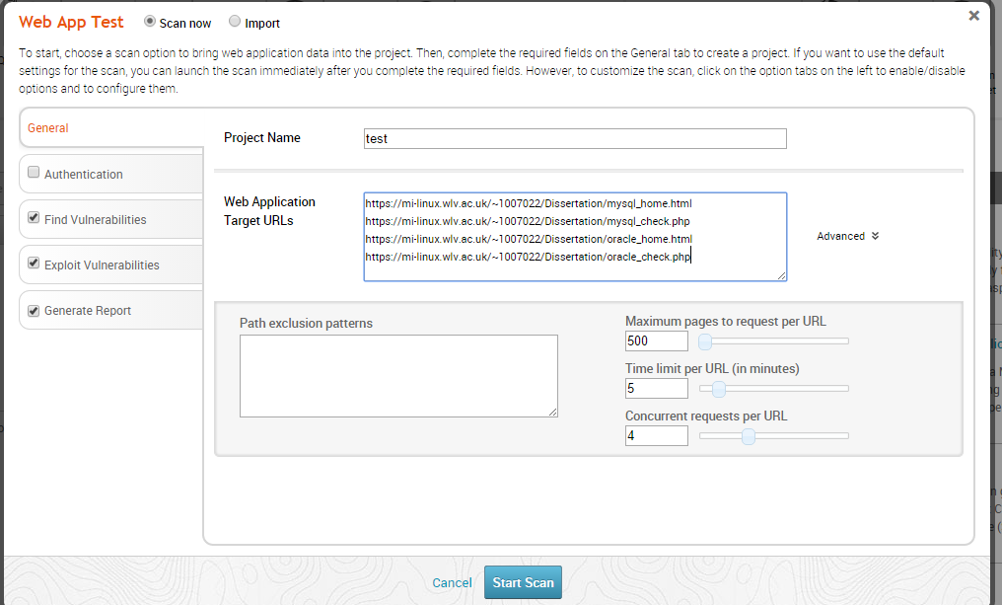The program allows for testing of a web applications security with several tools such as a penetration test, sending dubious emails, a full application test, vulnerability scanner and more.

The application test was configured to locate the targets, find and exploit and vulnerabilities they have, the results of which will generate a report.

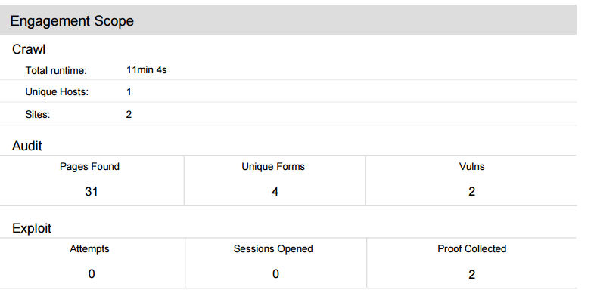

The program found two vulnerabilities.

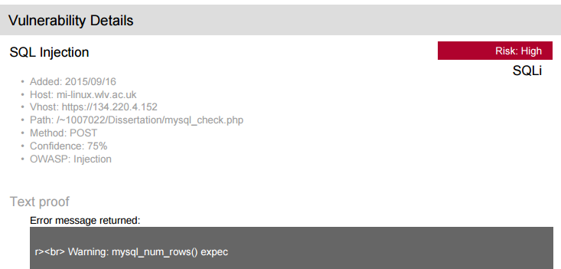

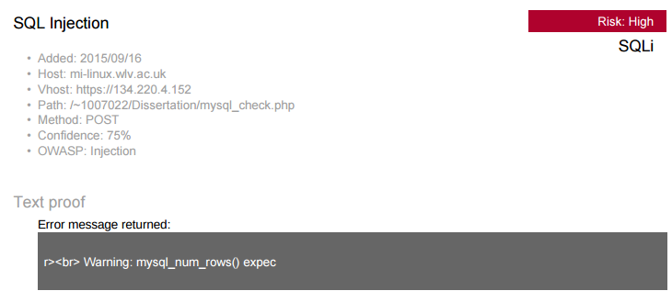

Both vulnerabilities are shown in detail to be SQLI vulnerabilities and provides advice on dealing with them, which outlines the programs usefulness in combating SQLIAs.